12th European Championships 2018, Poland, Lublin
Coach Report

82 - Personal bests,
19 - Age group
3 - Scottish records
4- Isle of Man records
7- English records
5 - GB records
2 - GB Relay records
1 - European Championship Record
3 Bronze Medals

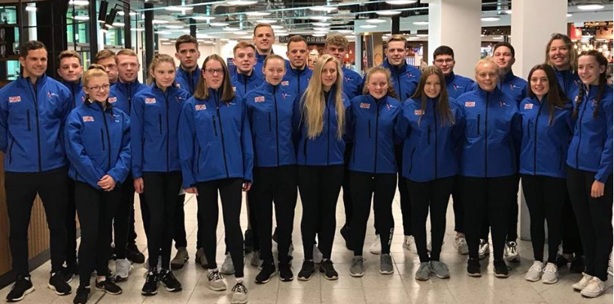

Congratulations to all the swimmers who participated in another successful Europeans in Lublin Poland 2018. I was really honoured as coach to have this fantastic opportunity to support nineteen dedicated swimmers, the largest squad that we have ever taken abroad to compete internationally. There were ten young swimmers competing internationally for the first time, and nine experienced swimmers. We also had three new officials, Rebecca Gotta as Team Manager, Polly Saines and Matthew Oaten as Trainee Officials and I as Head Coach.

Overall the team was fantastic and as Coach I was pleased with every swimmers performance. The competition schedule was slightly longer than normal and because it ran for six days the events were more spread out, allowing more recovery time in between races for the swimmers. All the facilities and the competition pool were excellent and met all the required standards for the event. As coach I was excited and inspired to be able to watch the team compete at this fantastic venue.

The team achieved 3 bronze medals and many PBs /records

Jack McComish (3Bronze) 50 Freestyle, 50/100 Breaststroke
(4th) 200 Breaststroke

Oliver Kenny (4th) 100/200 Backstroke
(7th) 50 Backstroke, 200 Individual Medley
(8th) 100 Butterfly

Nathan Young (6th) 100 Butterfly
(7th) 50/200 Butterfly, 100 Freestyle

Kieran Holdbrook (6th) 1500 Freestyle

Lucy Sharp (5th) 50 Butterfly
(7th) 50/100Freestyle, 50 Backstroke
(8th) 400 Freestyle

Libby Gotta (5th) 400 Individual Medley
(6th) 200 Individual Medley, 100 Butterfly, 200 Backstroke
(7th) 100 Backstroke
(8th) 50 Backstroke

Ciara Tappenden (5th) 800 Freestyle
(6th) 400 Freestyle

Lucy Jorden-Caws (5th) 200 Butterfly

Shiona McClafferty (7th) 200 Breaststroke
(8th) 100 Breaststroke, 200 Individual Medley

Grace McNiff (8th) 50 Butterfly

Letisha Ellis just missed out in the final coming 9th in the 200 breaststroke, and Zack Merritt also came 9thin his 1500m. Also great races from Luke Nisted, Sam Merritt, Kieron Harris, Lewis McCulloch, Fraser McCulloch, Jess Oaten, Katie Taylor who all swam brilliantly, breaking records and achieving personal bests in their individual races.

The team was also unlucky not to medal in the relays. We achieved 6 fourth places and 2 fifth places. British records were broken in the Men’s 4 x 100 & 4 x 200 Freestyle relays. Both were thrilling to watch and I was impressed with how well the teams performed in all the relays, both heats and finals.

Shown at the top is the number of records broken in each British country. Overall in the medals table Great Britain came 7th with a total of 3 medals. This was less than my overall target as Coach but I was proud to see a British swimmer in nearly every final, and to achieve 82 personal bests shows how much we are improving. For the young swimmers competing internationally for the first time, this was an opportunity for them to gain the confidence and knowledge needed to enable them to win medals in the future. As head coach I was honoured to support the swimmers and to help them achieve their best performance. I would like to thank all the staff Rebecca, Polly and Matt, for their help and support, without them the team would not have been as successful. I would also like to thank the parents for their time at the poolside and for supporting the swimmers throughout.

Sam Chamberlain
Head Coach

